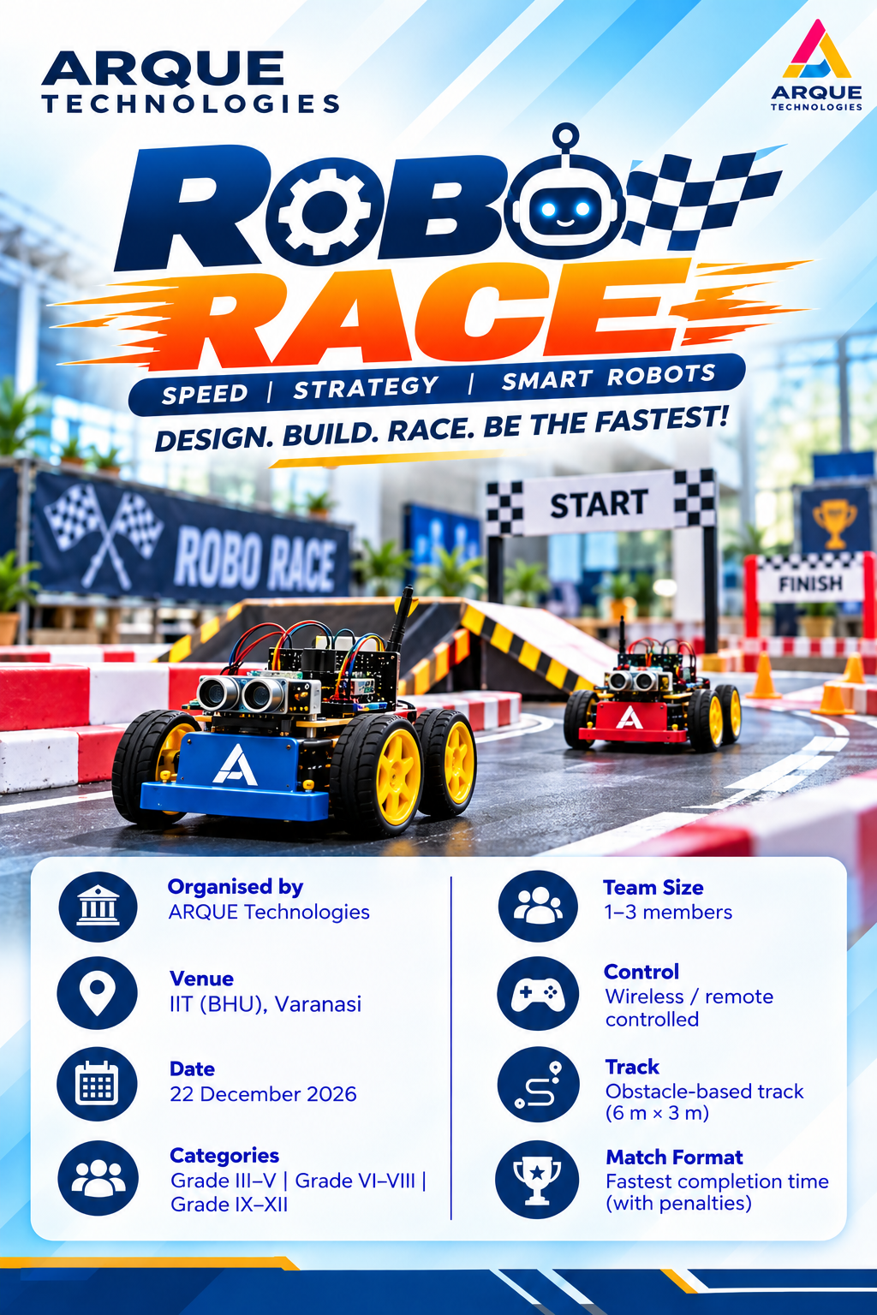

TECH MANTHAN
IDEAS | INNOVATION | IMPACT
ROBO RACE
SPEED | STRATEGY | SMART ROBOTS
DESIGN. BUILD. RACE. BE THE FASTEST!
A manually controlled robotics challenge in which teams build and operate a wheeled robot to complete an obstacle track in the shortest valid time, while following all safety and technical rules.

1. Event Overview
Robo Race is a hands-on robotics competition that tests robot design, control, speed, and strategy. Teams must guide their robots through a defined track featuring turns and obstacles. The winner is determined by the lowest adjusted completion time, including applicable penalties.

2. Event Details
DETAIL | INFORMATION
Event | Tech Manthan – Robo Race
Organizer | ARQUE Technologies
Venue / Selection | Offline at IIT (BHU), Varanasi
Categories | Elementary: Classes 3–5; Junior: Classes 6–8; Senior: Classes 9–12
Team Size | Maximum 3 students per team
Registration Fee | ₹899 per team

3. Robot Specifications
PARAMETER | RECOMMENDED LIMIT
Maximum length | 20 cm
Maximum width | 20 cm
Maximum height | 20 cm
Maximum weight | 5 kg
Power source | On-board battery only
Maximum voltage | 12 V DC
Drive | Wheels / rubber tyres
Control | Wireless
Controller | Any microcontroller

4. Robot Construction & Components
- Robots must be designed for a wheeled race on the announced obstacle track.
- All components must be securely mounted; wiring and batteries must be insulated and safely fixed.
- The robot must use an on-board battery-powered system within the maximum 12 V DC limit.
- The robot must be wirelessly controlled from the designated control area.
- The robot must pass the pre-race inspection before competing.

5. Prohibited Robot Features
- Sharp blades, spikes, cutting tools, or weapons.
- Flammable, explosive, corrosive, or toxic materials.
- Water, oil, or chemical spraying mechanisms.
- High-pressure pneumatic or hydraulic systems unless specifically approved.
- Projectile-launching mechanisms.
- Magnets or adhesives intended to damage or stick the robot to the arena.
- Any mechanism designed to damage the arena, obstacles, or another robot.
- Internal-combustion engines or fuel-powered systems.
- Commercial toy/ready-made racing cars, if the organizer specifies a build-focused event.

6. Race Format & Winning Criteria
- Two robots compete simultaneously, each in a separate starting lane.
- A maximum of 3 attempts will be given.
- Both robots start on the referee’s official START signal.
- Teams must operate their robots from the designated control area.
- The referee records the raw completion time and applicable penalties.
- Final time = raw completion time + penalty time.
- The robot with the lowest adjusted completion time wins. A robot that does not finish within the allowed time is marked DNF (Did Not Finish).

7. Arena / Track Specifications
ARENA PARAMETER | RECOMMENDED SPECIFICATION
Overall arena | 6 m × 3 m
Track width | 40–50 cm
Start box | At least 50 cm × 50 cm
Finish zone | At least 50 cm × 50 cm
Boundary height | 20 cm
Obstacle clearance | Minimum 10 cm around fixed obstacles
Surface | Level, non-slippery floor

8. Safety & Penalties
- Every robot must pass a pre-race inspection of dimensions, weight, battery, wiring, switch, and prohibited mechanisms.
- Touching a boundary: +5 seconds per occurrence.
- Robot leaves the track: +10 seconds; return to the previous checkpoint.
- Manual touch: +15 seconds; repositioning is allowed only with judge permission.
- Unauthorized assistance, arena damage, or an unsafe robot may lead to disqualification.
- If a robot gets stuck or leaves the track, the operator must not enter the arena without judge permission. A marshal/referee will reposition it at the previous checkpoint, and the applicable penalty will be added.
SMALL ROBOTS. BIG DREAMS. LET THE RACE BEGIN!
TECH MANTHAN • IDEAS | INNOVATION | IMPACT
ARQUE TECHNOLOGIES • Robotics Competition • IIT (BHU), Varanasi

