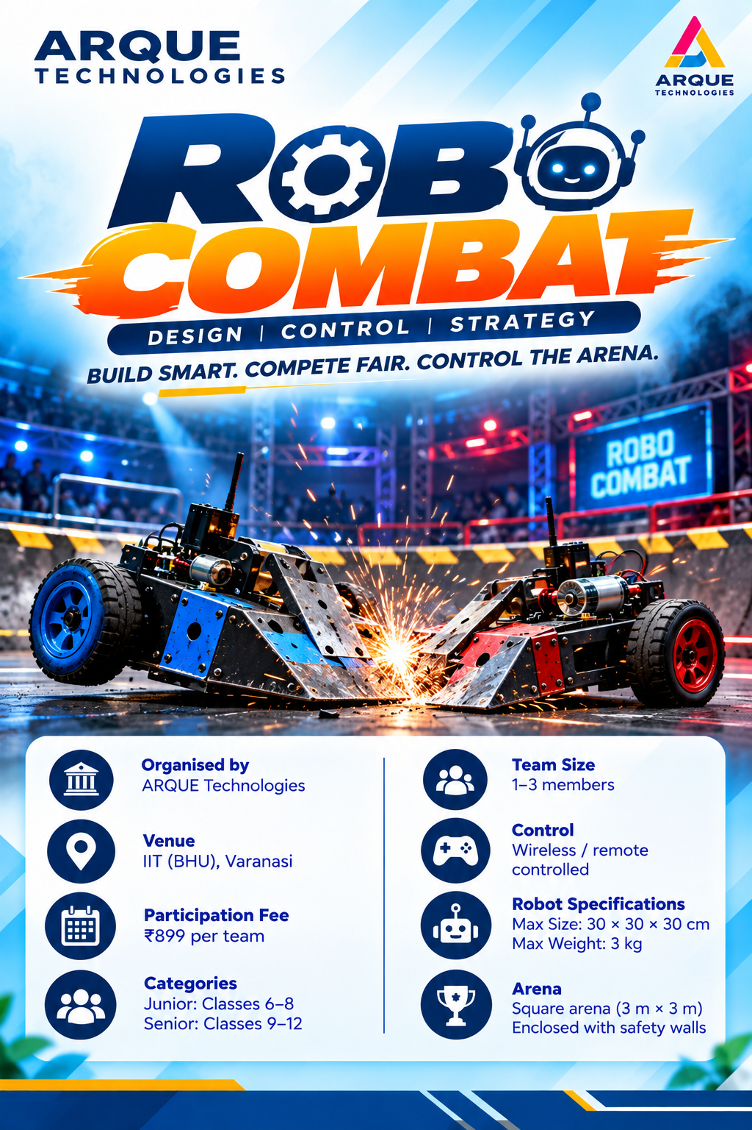
TECH MANTHAN
IDEAS | INNOVATION | IMPACT
ROBO COMBAT
DESIGN | CONTROL | STRATEGY
BUILD SMART. COMPETE FAIR. CONTROL THE ARENA.
Robo Combat is a robotics challenge in which teams design and operate a robot to compete against another robot in a controlled arena. The aim is to outmanoeuvre the opponent and score points while following all technical and safety rules.

1. Event Overview
Robo Combat tests robot engineering, remote control, tactical thinking, reliability, and teamwork. Matches take place in a designated arena under referee supervision. The competition should emphasize safe robot design and controlled matches; the organizer must publish final match rules and scoring criteria before the event.

2. Event Details
DETAIL | INFORMATION
Event | Tech Manthan – Robo Combat
Organizer | ARQUE Technologies
Venue / Selection | Offline at IIT (BHU), Varanasi
Categories | Junior: Classes 6–8; Senior: Classes 9–12
Team Size | 1–3 members
Registration Fee | ₹899 per team

3. Robot Specifications
PARAMETER | RECOMMENDED LIMIT
Maximum length | 20 cm
Maximum width | 20 cm
Maximum height | 20 cm
Maximum weight | 3 kg
Power source | On-board battery only
Maximum voltage | 12 V DC
Control | Wireless / remote controlled
Drive | Wheels or tracks
Controller | Arduino or another compatible controller

4. Team Composition
- Each team shall consist of 1–3 members.
- Each team must nominate one Team Captain.
- One registered member will operate the robot during a match.
- Only registered team members may handle the robot in the competition area.

5. Permitted Components
- Arduino Uno or another compatible microcontroller / approved robot controller.
- Motor drivers and geared DC motors suitable for the robot.
- Wheels or tracks securely attached to the chassis.
- Chassis made from acrylic, MDF, plywood, plastic, aluminium, or other approved materials.
- Wireless control modules or approved remote-control systems.
- Rechargeable battery pack within the announced voltage limit.
- Switches, fuses, connectors, jumper wires, and standard electronic components.
- Non-sharp, non-projectile contact mechanisms or pushing attachments, only if permitted by event rules and the technical judge.

6. Prohibited Robot Features
- Sharp blades, cutting edges, spikes, or exposed sharp parts.
- Fire, flames, explosives, flammable liquids, corrosive or toxic materials.
- Projectile-launching systems or mechanisms that throw objects.
- Water, oil, chemical, smoke, or other substance-spraying mechanisms.
- High-voltage systems or exposed electrical connections that create a hazard.
- High-pressure pneumatic or hydraulic systems unless specifically approved in writing.
- Entangling wires, nets, adhesives, magnets, or mechanisms intended to damage or immobilize an opponent unsafely.
- Any mechanism designed to injure participants, damage the arena, or create an uncontrolled hazard.
- Fuel-powered engines or internal-combustion systems.
- Commercial ready-made combat toys, if the organizer requires student-built robots.

7. Arena Specifications
PARAMETER | RECOMMENDED SPECIFICATION
Arena shape | Square or rectangular enclosed arena
Suggested size | 3 m × 3 m
Boundary | Raised, secure perimeter wall
Surface | Flat, stable, non-slippery floor
Safety zone | Clear area around the arena for teams and spectators
Access | Only referee-authorized personnel may enter the arena during a match

8. Match Format & Scoring
- Robots must pass technical and safety inspection before each match.
- Two robots compete in the arena at a time, unless the organizer announces a different format.
- Each match begins and ends on the referee’s signal.
- Suggested match duration: 2 minutes, subject to the published event schedule.
- Judges may award points for controlled pushing, effective manoeuvring, and maintaining active control, if these criteria are announced in advance.
- A robot that is immobilized, exits the arena, or cannot continue may lose the match, subject to the published rules.
- If scores are tied, the referee may declare a draw or arrange a tie-breaker round.

9. Safety Rules & Penalties
- Every robot must pass inspection for dimensions, weight, battery, wiring, moving parts, and prohibited features.
- Robots must be switched off before being picked up, repaired, or adjusted.
- Operators must remain in the designated control area and follow the referee’s instructions.
- Unauthorized entry into the arena, unsafe conduct, or interference with another team may result in a warning or disqualification.
- Use of a prohibited feature, deliberate arena damage, or a robot judged unsafe may result in immediate disqualification.
- The referee may stop a match at any time if a safety risk arises.

10. Inspection & Winning Criteria
- Technical inspection is mandatory before participation.
- Teams must repair and re-present any robot that fails inspection; it may not compete until approved.
- The winner is determined by the announced scoring system, opponent immobilization under the rules, or judge decision where applicable.
- Judges’ decisions on safety and match conduct are final, subject to the event’s published appeal process.

11. Disqualification
- Using prohibited materials or mechanisms.
- Deliberately damaging the arena or attempting to injure people.
- Unauthorized physical assistance during a match.
- Tampering with another team’s robot or control system.
- Operating an unsafe robot or ignoring the referee’s stop signal.
- Unsportsmanlike or disrespectful conduct toward judges, volunteers, or other teams.
BUILD SMART. COMPETE FAIR. LET THE BATTLE BEGIN!
ARQUE TECHNOLOGIES • TECH MANTHAN
Robotics & Artificial Intelligence Competition • IIT (BHU), Varanasi

