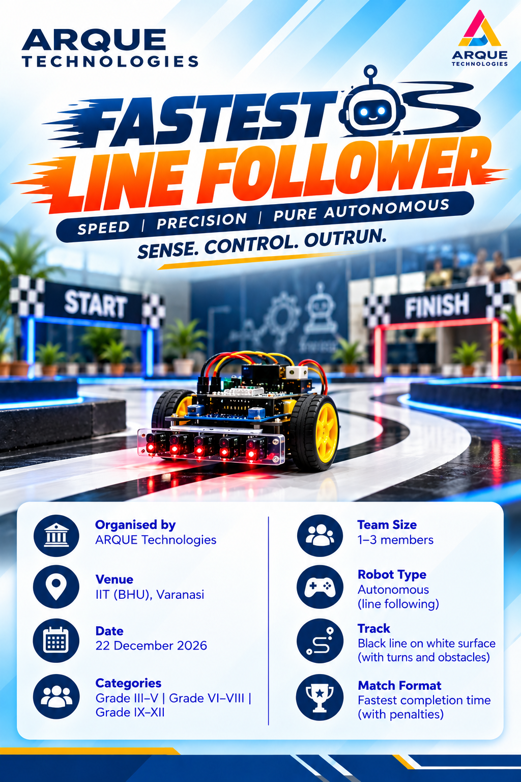

TECH MANTHAN
IDEAS | INNOVATION | IMPACT
FASTEST LINE FOLLOWER
SPEED • PRECISION • PURE AUTONOMOUS ROBOTICS
DESIGN. BUILD. CALIBRATE. RACE.
An autonomous robotics challenge in which teams design and program a robot to follow a contrasting line and complete the track in the shortest valid time.

1. Event Overview
The Fastest Line Follower is an autonomous robotics competition. The robot uses reflectance sensors to detect a line on a contrasting surface, processes sensor readings through an onboard controller, and adjusts the left and right motor speeds to stay on course. The winner is the team that records the lowest valid adjusted completion time, subject to the official event rules.

2. Event Details
DETAIL | INFORMATION
Event | Tech Manthan – Fastest Line Follower
Organizer | ARQUE Technologies
Venue | IIT (BHU), Varanasi
Event Date | 22 December 2026
Categories | Elementary: Classes 3–5; Junior: Classes 6–8; Senior: Classes 9–12
Team Size | Maximum 3 students per team
Control Mode | Fully autonomous; no manual steering during a run
Attempts | Two attempts per team (reference format; final schedule is set by organisers

3. Robot Specifications
PARAMETER | REFERENCE SPECIFICATION
Maximum dimensions | 20 × 20 × 20 cm
Maximum weight | 3 kg
Controller | Arduino Nano, ESP32, or another suitable microcontroller
Line sensor | Reflectance / IR sensor array; 5–8 sensors recommended
Motor driver | L298N or another appropriately rated H-bridge
Drive system | Two DC geared motors with matched wheels
Power | On-board battery pack 9V; secure mounting and suitable regulation
Operation | Autonomous line detection and motor-speed control

4. Track and Race Procedure
The supplied proposal uses a black line on a white surface as the reference track. The sample line width is approximately 2 cm, and the proposed track length is 10–15 m. The final track layout, surface, start procedure and time limit will be announced by the organisers before the competition.
- Each team must bring its own robot and pass the technical inspection before competing.
- The robot must follow the line autonomously using onboard sensors and control logic.
- Teams may calibrate and test the robot only during the time and in the area permitted by the organisers.
- The referee starts and records each run. External assistance during a run is not permitted.
- The reference proposal specifies a 60-second run limit; the official time limit will be confirmed by organisers.

5. Competition Rules & Winning Criteria
RULE | REFERENCE FORMAT
Autonomy | Robot must complete the track without manual control.
Attempts | Two attempts per team; the best valid time is used in the reference format.
Track reveal | Track may be revealed shortly before the event; organiser instructions prevail.
Modifications | No hardware or software changes after the first attempt in the sample format.
Touching / assistance | External assistance or touching the robot during a run may result in a penalty or disqualification.
Line loss / leaving track | Penalty or restart procedure will be specified by the organisers.
Winner | Lowest valid completion time, including any applicable penalties.
DNF | A run that does not finish within the permitted time may be recorded as Did Not Finish.

Note: The rules above are adapted from the supplied proposal and are reference rules. Any final event-specific rule announced by the organisers takes precedence.

6. Safety & Technical Inspection
- Battery must be undamaged, correctly rated and securely mounted.
- Power switch must be accessible; wiring and connectors must be insulated and secured.
- Motors, wheels, sensor array and chassis must be firmly mounted; no sharp exposed edges.
- The robot must not start moving unexpectedly when powered on.
- The robot must stop safely and recover predictably if it loses the line.
- Charging, soldering and workshop tools must be used under adult/educator supervision.

7. High-Speed Tuning Guidance
- Remove unnecessary weight and keep wiring short and secure.
- Mount the sensor array rigidly at a consistent height above the track.
- Use matched wheels with good grip and choose motors for both speed and torque.
- Start at moderate speed; tune Kp for response and Kd to reduce oscillation.
- Increase base speed gradually and retest the most difficult curves.
- Record repeated timed runs and select the fastest repeatable settings, not a single lucky run.

8. Disqualification / Penalties
- Manual steering or outside control during a run.
- Unauthorised physical assistance or modification after the attempt begins.
- Unsafe battery, exposed wiring, prohibited mechanism, or damage to the track.
- Failure to follow referee instructions or interference with another participant.
The exact penalties, restart conditions and disqualification decisions will be determined by the event organisers and judges.

9. Final Readiness Checklist
CHECK | READY
Official event rules and track details checked | ☐
Robot dimensions and weight verified | ☐
Motors and wheels checked | ☐
Battery secure; wiring insulated | ☐
Technical inspection passed | ☐

SMALL ROBOTS. BIG DREAMS. FOLLOW THE LINE. WIN THE TIME!

